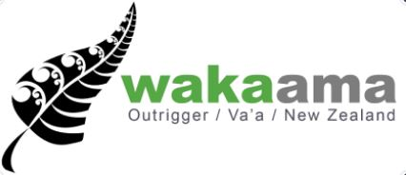
Waka Ama New Zealand
Media Liaison – Paid Internship (Auckland based)

Experience
Suitable for a student in their final year of media or communications study, someone with previous media experience, or just a social media guru. Knowledge of Waka Ama would be beneficial.
Duration:
End December 2018 – February 2019
Key Event dates:
13-20 January at Lake Karāpiro. - Waka Ama National Sprint Championships (accommodation and food provided)
15- 17 February at Takapuna Beach – Takapuna Beach Cup
Paid Internship – 14 weeks. Approx. 120 hours total $3000
Hours will be flexible outside of event dates and would be around 2-4 hours per week outside of the events. During events full days would be required.
Key tasks
Responsible for overseeing communications to the media, preparing articles, press releases, driving social media content and manages relationships with media reps. Will work with Waka Ama NZ staff for the delivery and conception of ideas.
National Sprint Championship
- Social media updates daily, Facebook and Instagram
- Daily media release
- Liaise with media stakeholders at the event
- Complete a media plan
- Identify and develop new media opportunities
Takapuna Beach Cup
- Social media updates daily, Facebook and Instagram
- Daily media release
- On water live feeds
- Identify and develop new media opportunities
This is a flexible role that allows for the candidate to use initiative and creativity in designing a media strategy while also getting real world experience. Waka Ama NZ staff will brief the successful candidate in what is currently competed and will be able to assist throughout the internship.

If this sounds like you and you want to become part of the Waka Ama NZ team please send a CV and one page cover letter to admin@wakaama.co.nz by 17th December 2018 5.00pm

